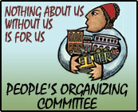
People’s Organizing Committee
Return, Rebuild, Resist!
www.peoplesorganizing.org
Volume 2, Number 1 * February, 2007

Public Housing Residents Take Back Their Homes
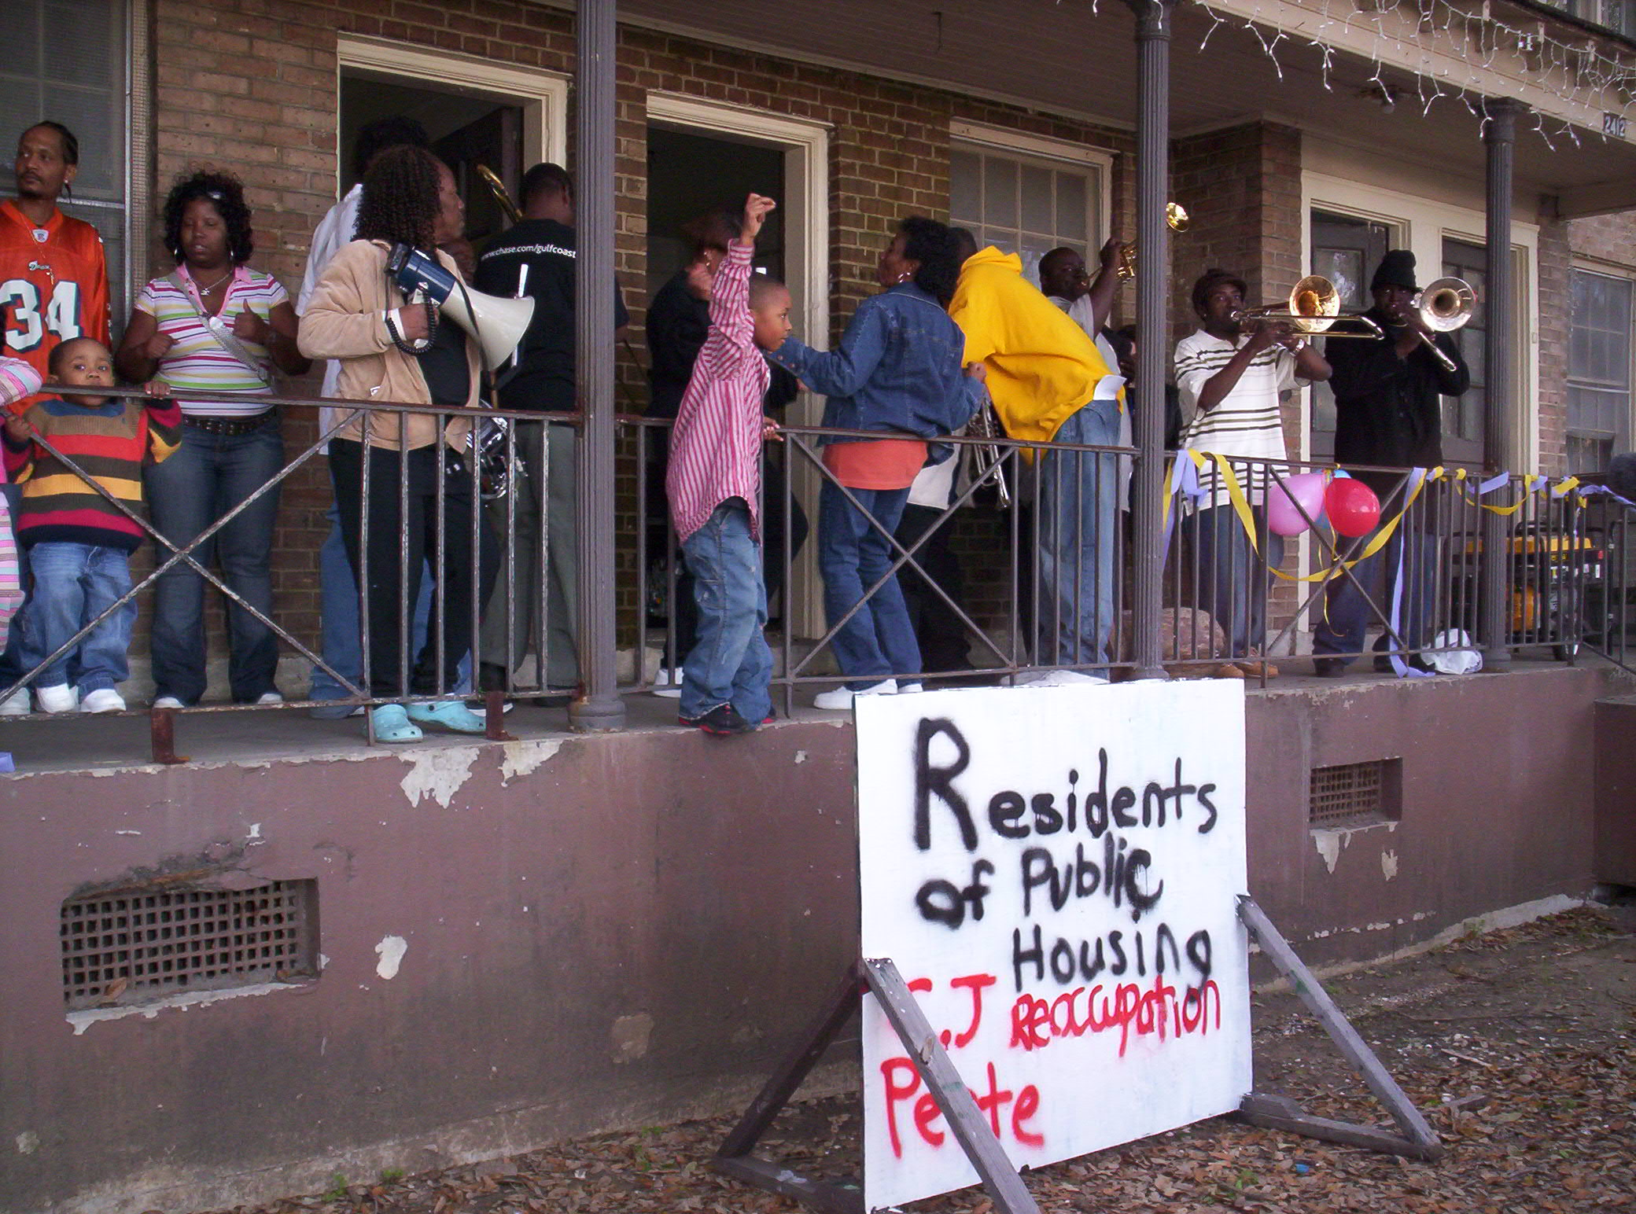
C.J. Pete resident families celebrate move-in

February 10 was a historic day in New Orleans. Residents of the C.J. Pete public housing development moved back into their homes, which the government had slated for demolition.

Although Hurricane Katrina did not seriously damage the buildings HANO and HUD used the excuse to evacuate all the public housing in the city and lock the residents out of their homes. Then they decided to demolish the public housing and replace it with so-called mixed-income housing, which basically means most people would never be able to come home.

In all previous hurricane evacuations, residents were able to come back to their homes after the storm passed. In this case, they were not even allowed to come back and get their belongings. Tens of thousands of residents evacuated to distant cities or trailer parks have not been able to get home at all. The government later broke into the apartments to throw refrigerators down stairs, breaking doors off hinges and leaving the units open to widespread looting and destruction, including theft of pipes and electrical fixtures. The $10,000 the government offered some residents can never cover what they have lost, including baby pictures, diplomas and other sentimental personal items. And still HANO and HUD have claimed that it would be illegal for the residents, who hold valid leases to their apartments, to come home.

Despite all of this, public housing residents have come together over the past several months and formed an organization, Residents of Public Housing, which is part of the New Orleans Survivor Council. They decided to move back home.

People’s Organizing Committee, which is committed to developing and following the leadership of those most affected by Katrina, helped provide support for the residents’ move. At the direction of the residents, they cleaned apartments, obtained generators to provide light and heat, canvassed the surrounding neighborhood to explain the move and build support, and sent out a press release for the residents’ press conference. At this writing, two dozen volunteers from a high school in New Jersey are working for the residents, cleaning out more apartments in the complex.

The move and the press conference were managed and led entirely by the residents themselves. Six residents spoke before the cameras about their determination to come home. “The government wanted us to get out and stay out,” said one resident. “I voted for Nagin, but he did nothing for us. They want black people out of New Orleans, and they figured this was one group they could get rid of. But nothing is going to stop us from coming home. C.J. Pete is back!”

This event was a change from earlier public housing reoccupations. Some of them were mainly symbolic, and in most cases, people who were not residents took a major hand in leading them. A few weeks ago, when residents attempted to move back into a different development, the rally and speeches were mainly led by white activists, not by the residents. This displayed a lack of respect for the black residents, who are not only capable of leading their own movement, but on principle should be leading it. Racism in America has created a situation where poor, black working class people are so marginalized and disrespected that even many politically progressive groups and individuals don’t trust them to organize and lead their own fight. POC is dedicated to bottom-up leadership, so its role was to provide every possible support and encouragement to the residents to lead themselves.

About 60 people, residents and supporters, came to the press conference and support rally. Balloons decorated the front porch of the newly opened units. A big sign announced the reoccupation. Residents took turns speaking on a bullhorn to the assembled crowd and passers by, repeating for all to hear that C.J. Pete is back to stay. The Community Kitchen donated food for the event. Residents also thanked organizations that donated generators, including Hope House, the Workers’ Center and Moving Forward Gulf Coast. And The Hot 8, a second line band played at the end, while residents danced and sang along in a happy celebration of their victory. “I don’t know what you’ve been told, but the projects is livable!” went the words to the last song. This chant echoed as supporters drifted away and residents went back to the work of settling into their new apartments.
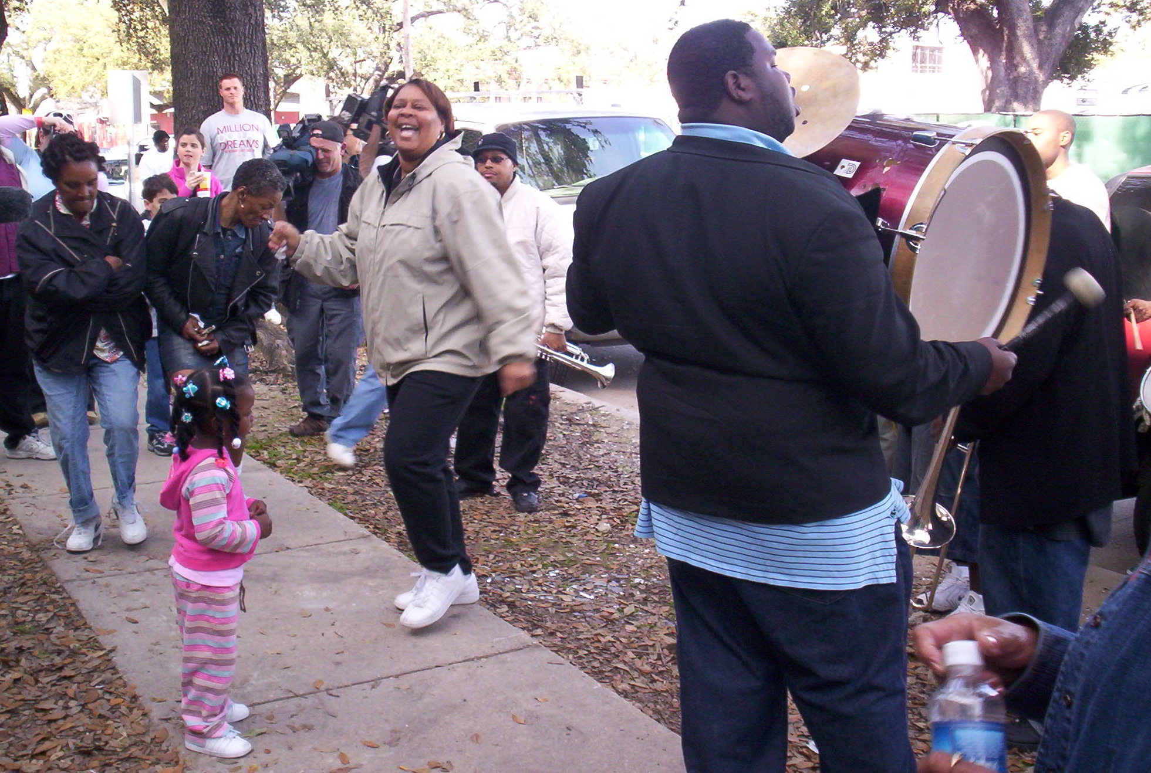
Residents dance to the music of the Hot 8 after their press conference

Residents and POC staff provided a security watch through the night, aware that HANO could descend on them at any moment and try to evict them. The residents will remain vigilant to defend their homes.

Meanwhile, on the wave of this victory, Residents of Public Housing is making plans for reoccupying the next development, the Lafitte projects. Their intention is to open all the projects now slated for demolition and bring their communities back.
Support Public Housing Residents! Donate to:
IFCO/New Orleans Survivor Council
418 W. 145th Street
New York, NY 10031

HANO Evicts C.J. Peete Residents into the Cold Night
The Struggle Continues!

At 11 PM on Valentine’s Day, the Housing Authority of New Orleans (HANO) sent a message to the courageous families that had reoccupied C.J. Peete that their families would lose their housing vouchers and they would be declared in violation of their leases if they remained in their homes.

HANO had arranged for public housing residents to get Section 8 vouchers in order to keep them from moving back into their original homes. Faced with the prospect of their children and elders being homeless, the occupiers felt they had to submit to this pressure. However, they are definitely NOT giving up the fight!

At this writing, Residents of Public Housing is finding C.J. Peete residents who are willing to move back in, face arrest, put their families at risk, and take HANO to court about what is surely an illegal attack on their rights. Several people have come forward so far. Meanwhile, residents of Lafitte are also ready to reoccupy, face arrest, put their families at risk and go to court.

Stay tuned: the story is sure to get hotter!

Katrina Survivors and Immigrant Workers Unite to Arrest Slave Owner

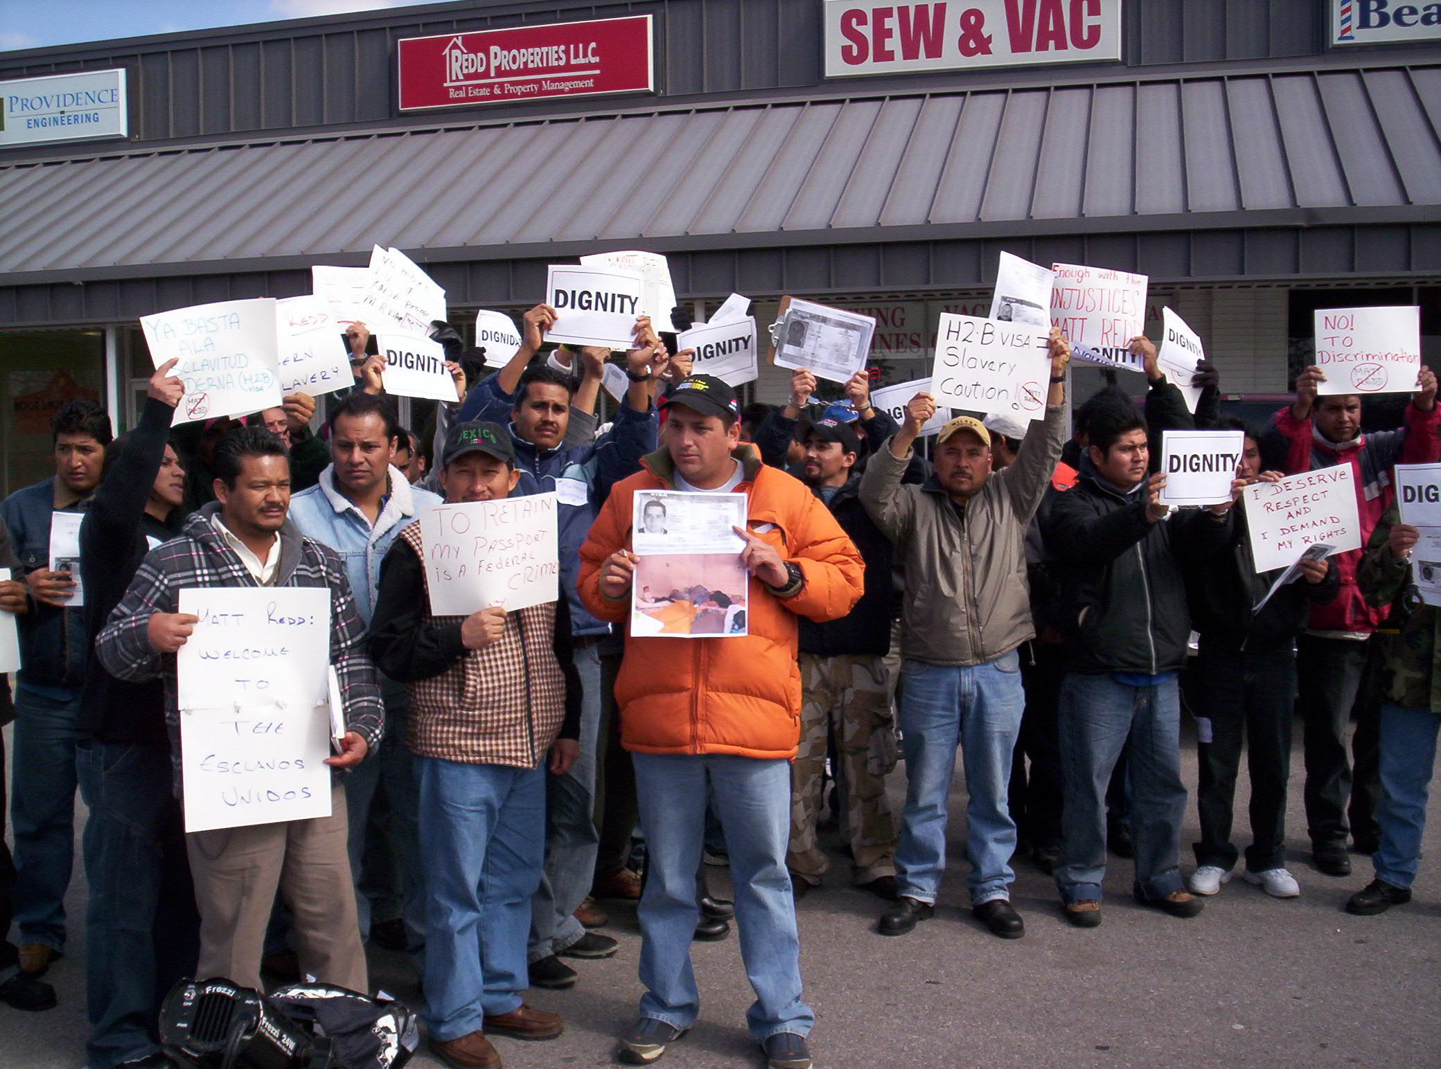
Guest workers demand arrest of their slave boss, Matt Redd, at his office.

February 15, 2007
Poor black working class New Orleans residents are facing the worst racist attack in decades. At the same time, immigrant workers from Central and South America are being trafficked as slaves in New Orleans and across Louisiana. These two groups have come together to arrest one of the slave owners and traffickers.

Public housing residents who just last Saturday reoccupied their homes in the C.J. Peete housing development were told last night, Wednesday, February 14, that they must vacate their units or lose their vouchers. This would leave their extended families homeless. Today, young volunteers from New Jersey who have been helping to clean up the development were threatened with arrest for their efforts to help the residents.

Despite this emergency, when organizers from the New Orleans Survivor Council heard that immigrant workers had located their slave owner and were ready to execute a citizen’s arrest, they left New Orleans to come help their brothers and sisters.

Slave trafficker Matt Redd has been holding about one hundred Mexican workers as virtual slaves near Lake Charles, Louisiana. About forty of these workers, accompanied by supporters from the New Orleans Survivor Council, walked to the offices of Redd Properties in Sulphur, LA to attempt to execute a citizen’s arrest.
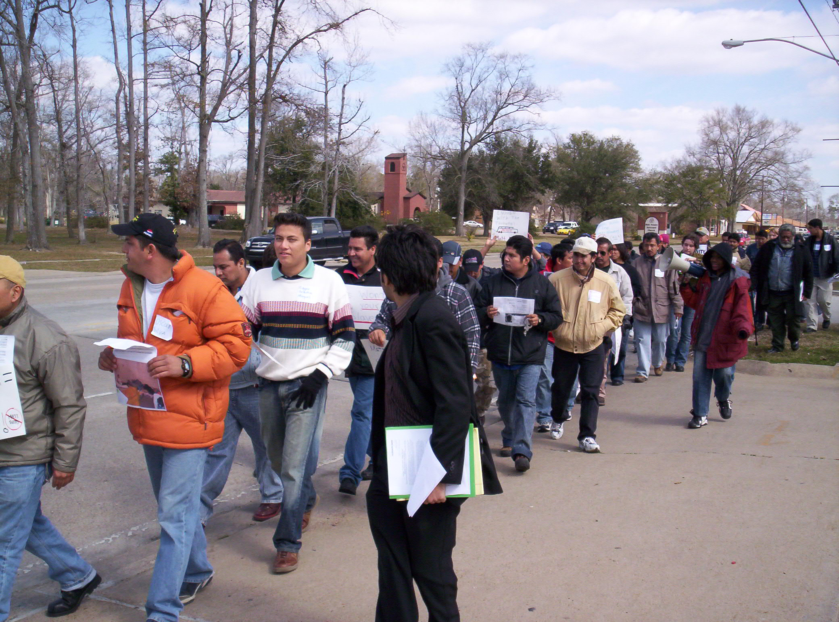
Workers and supporters march to Matt Redd’s office

At a press conference in a CVS parking lot, just before going to Redd’s office, workers told the press that Redd had taken their passports without their consent at the US consulate in Mexico where they obtained their H2B (guest worker) visas. Redd then charged them plane fare and then put them in vans to bring them to Louisiana, where he leased them out to low-wage employers in restaurants, car washes and municipal waste management. He also recently imported dozens of skilled pipe fitters and welders, who have not worked in the two weeks they’ve been in the country. These workers have had no income, and because they do not have their passports, they can’t even go home. One worker told the press that his mother needed blood for a liver operation, and that he was the only family member whose blood was a match for hers, but he is unable to return because he doesn’t have his passport. In the past several days, Redd had begun firing workers for circulating a petition demanding their passports back.

A spokesperson for the New Orleans Survivor Council told the immigrant workers the words to some freedom songs: “before I’ll be a slave, I’ll be buried in my grave,” and “we who believe in freedom cannot rest until it comes.” He pointed out that a carload of NOSC organizers had come to join them in making the citizen’s arrest despite the fact that at 11:30 the night before, residents who had reoccupied their public housing units were put out in the street by the Housing Authority on one of the coldest nights of the winter. Even so, the speaker said, “we are all the same people, the only thing that separates us is language; and we who believe in freedom cannot rest until it comes.”

The citizen’s arrest statement said in part, “You are officially accused of taking an official passport of a person and refusing to return it in order to prevent the movement and travel of that worker without lawful authority in order to maintain the labor of that worker – this is a felony under the law of the United States of America.” The statement quoted the particular U.S. and Louisiana laws against slavery and trafficking in slaves, and pointed out that it is the right of a private person to make an arrest of a person who has committed a felony. That person can then hold the criminal until law enforcement comes to take him into custody, or can take him to law enforcement.

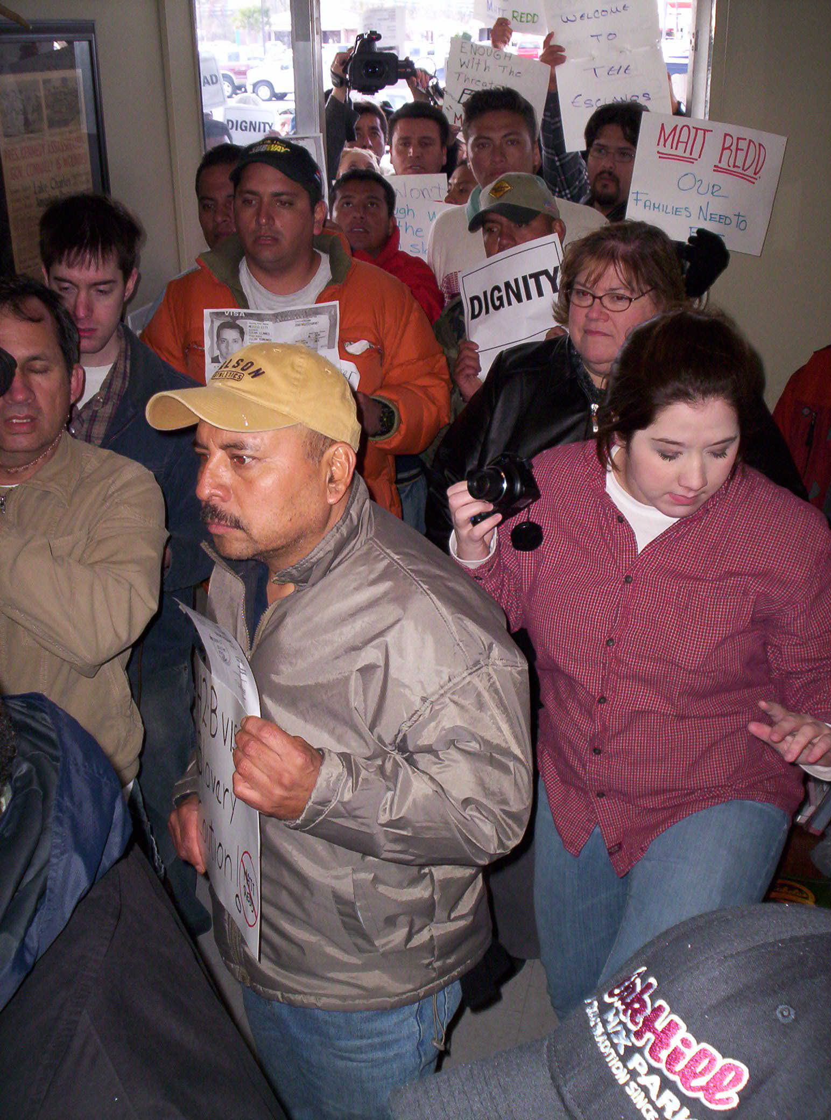
H2B workers look for slave boss in his office

Redd was not in his office, but the group had notified law enforcement agencies of their intention to make an arrest, so when they arrived at the office they demanded law enforcement find and arrest him. Sheriff’s police must have been a little worried about openly defending slavery while the press cameras were rolling, and they quickly worked out an agreement with Redd by phone to give back the passports of the workers present. The Sheriff’s office took possession of the passports and returned them to the workers, but the workers are still adamant in their demand that Redd be arrested for violating the anti-slavery laws. They vowed to continue their struggle, and to make sure that all passports Redd is holding will be returned to their owners. Meanwhile, the Survivor Council members jumped back in their cars to return to the struggle to reopen public housing, to rebuild the homes of black residents the government doesn’t want to come home, and to continue its campaign to build a world-class levee around the Lower Ninth ward.

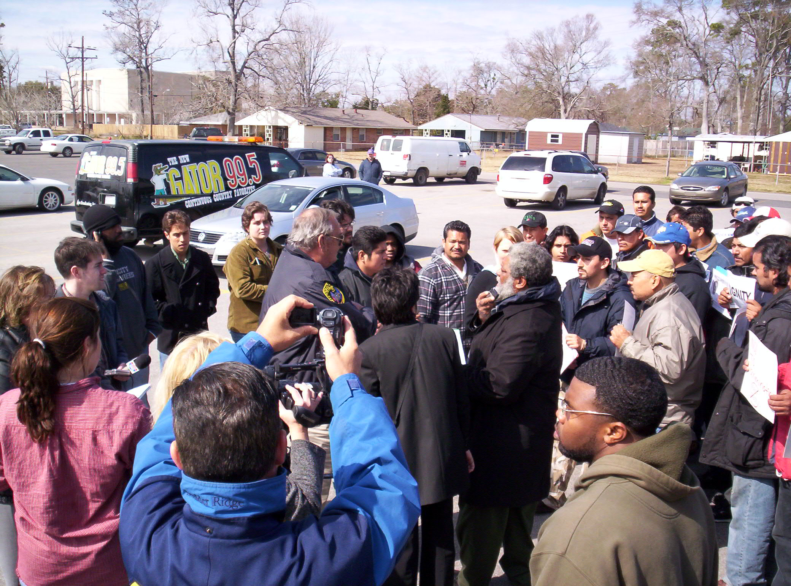
Workers demand Sheriff’s office arrest Redd for slavery

These beginnings of unity between black New Orleans hurricane survivors and immigrant guest workers – the descendants of the old slaves uniting with the modern day slaves – is a very significant event. As one of the Sheriffs pointed out, it was the U.S. government itself that gave the passports to the slaveholder. Just as in the days of African slavery, the government is on the side of the owners. When the descendants of the former slaves were asked what should be the next step, they suggested filing suit against the government of the United States for being an accomplice to slave owning and trafficking.

NOSC Goes to Venezuela to Get Support

Just after Katrina, the government of Venezuela gave money to the people of New Orleans. The U.S. government directed that money to the Red Cross, not the people. This month, NOSC members are going to Venezuela to get support directly into the hands of the people on the bottom. The following is the statement they are carrying to the people of Venezuela

We are a group of survivors and organizers working for the people who were left to die when New Orleans flooded after Hurricane Katrina. We are visiting your country for the second time on an urgent mission on February 19 to 25 to appeal to you as friends of the poor, black, working class people of New Orleans. We need your help and support, as our government has attacked us and then turned its back on our desperate needs.

When Katrina threatened our city, local and national government united to keep us in the city as the floodwaters rose. The poorest and darkest skinned of working class people were left to die, and more than 6,000 of us did. We were herded into shelters with no food or water, and later dispersed all over the country with no way to get back home. A quarter of a million Katrina survivors are still scattered all over the country, and tens of thousands of us are living in trailer camps that are like concentration camps. Until now, the government has put every possible obstacle in our way, has not rebuilt our neighborhoods and has not even built levees around them that would keep out the water in the next hurricane. They closed the public hospital and most of the schools. Even the public housing units thousands of us lived in are scheduled to be torn down, though the flood did not damage them. Some residents moved back in anyway, and this week heavily armed special police units have kicked in the doors at 2 AM to throw people out and arrest them.

To replace us in the jobs we once held, the government has brought in so-called guest workers from Latin American countries, who they tell a pile of lies to get them here. Then they house them in trailer concentration camps, too, don’t give them medical care or safety protection, and pay them a fraction of what they used to pay us for the same jobs. These workers cannot quit their jobs without becoming illegal immigrants, so they are forced to work under these conditions. This is modern day slavery used to take the place of the descendants of their former slaves.

As former slaves and modern slaves, we are building unity. We realize that we must take our future into our own hands. The government has proven that it won’t help us. We are actively organizing to bring the poor, black working class communities back to our city and to unite with oppressed working people of other hues. We know that we all have the same oppressors, and in unity there is strength. We are one people. This is why we are coming to you to ask for your solidarity and support.

We have been struggling for over a year now to rebuild our communities and bring our families back home. However, it has become clear to us that we are being cast aside by the government and much of our society. Although everyday people have poured in to help us rebuild, no one with any resources has helped us. No money is coming to us from government or private sources, except the small donations of poor people like ourselves. We have come to see that the poorest black working class people in the United States today are in the same position that our ancestors were in on the Middle Passage from Africa, that Jews, Gypsies and other oppressed peoples in Europe were in during the 1930’s. Our young people are thrown in jail by the thousands and shot down in the streets by the police. Our access to health care is so poor that tens of thousands of us day of preventable causes in the richest country in the world. Our children cannot get a decent education and look to a future without a decent job. We are being set up for genocide, and few people see this, either in our country or internationally.

What is happening to us is important to every struggle in the world today. We are the descendants of the African slaves who built this country with their labor. We look around us in America and all the world, and we see that the darker your skin, the closer you are to the bottom of the heap. Like oppressed people everywhere, poor black people in the United States have always fought for freedom. We have a culture of resisting exploitation. We refuse to work hard for someone else’s profit. We fought slavery; we joined the army in large numbers to fight fascism in Europe during World War Two, because we know racism when we see it; we rose up against racism and burned cities forty years ago. This is why the government is afraid of us and wants us out of New Orleans. What is happening to us is a prediction of what will happen across our country and throughout the world as the U.S. government sinks deeper into fascism and aggression. This is not our struggle alone, it is the struggle of all laboring, oppressed and shunned people of the world.
If We Don’t Think It, It Ain’t for Us
People’s Organizing Committee
2226 Ursulines 504-872-9591
New Orleans, LA 70119 www.peoplesorganizing.org

Send Donations to: IFCO; 418 W. 145th St.; New York, NY, 10031

When we first visited your country last year, we were excited by promises of help. We need that help desperately. We have to fight or die. We were very impressed by your young social workers. We ask that you send twenty-five of them for two years to help us organize the rebuilding of our communities. We also ask that you provide financial support for twenty-five Katrina survivors to be trained and supported as organizers. Our goal is to begin to rebuild the levee around our devastated neighborhoods to world-class standards by ourselves. The government has left us vulnerable to being swept away by the next flood. We appeal to you to help us fund a demonstration project that will rebuild one block of levee.

The rich want us to believe that as poor, working people, and dark-skinned people, we are not smart or skilled enough to run our own lives. On the contrary, we believe that it is the people on the bottom, all over the world, who have the skills, intelligence and humanity to run the world. Help us take a step toward international unity of the oppressed of all hues, under the leadership of the most oppressed, to stand up together. It is a necessity for the survival of all of us.

Thank you.
The New Orleans Survivor Council
The People’s Organizing Committee
The New Orleans Workers’ Center

If We Don’t Think It, It Ain’t for Us
People’s Organizing Committee
New Orleans Survivor Council
2226 Ursulines 504-872-9591
New Orleans, LA 70119 www.peoplesorganizing.org
neworleanssurvivorcouncil@gmail.com
Send Donations to: IFCO; 418 W. 145th St.; New York, NY, 10031

An S.O.S. for Solar Panels and Electricians

The people of C.J. Pete and Lafitte will need proper electricity and plumbing to succeed in a permanent reoccupation. Even more important, they need to know that people across the country are following their struggle and supporting them.

We hope you can help! The residents are issuing an urgent call for support. They are in dire need of energy resources. We are issuing an S.O.S. call to anyone with experience and expertise in alternate energy services, such as solar panels, and any other available resources and expertise.

The eyes of the world are on New Orleans, and we CANNOT fail. We must make every possible effort to ensure the success of this action, and we need your help. Contact us IMEDIATELY with any knowledge or resources you have at your disposal.

Thank you in advance,
The Residents of Public Housing,
New Orleans Survivor Council

Call us at 504-872-9591
E-mail: neworleanssurvivorcouncil@gmail.com


